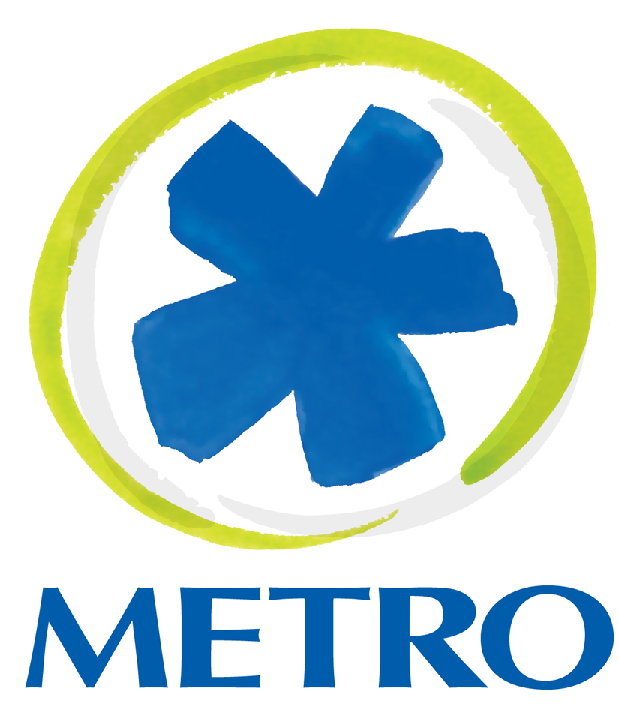

Contact:
Brandy Jones, APR
External Affairs Manager
(513) 632-7527
(513) 254-2587(cell)
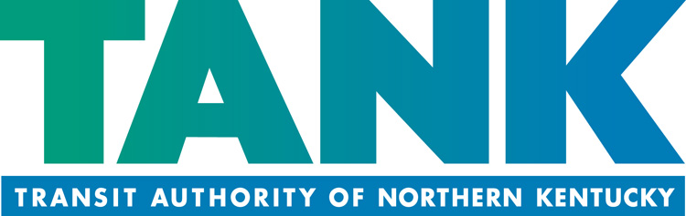
Contact:
Gina Douthat
Director of Communications
(859) 814-2125
(513) 470-8771 (cell)

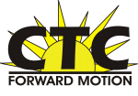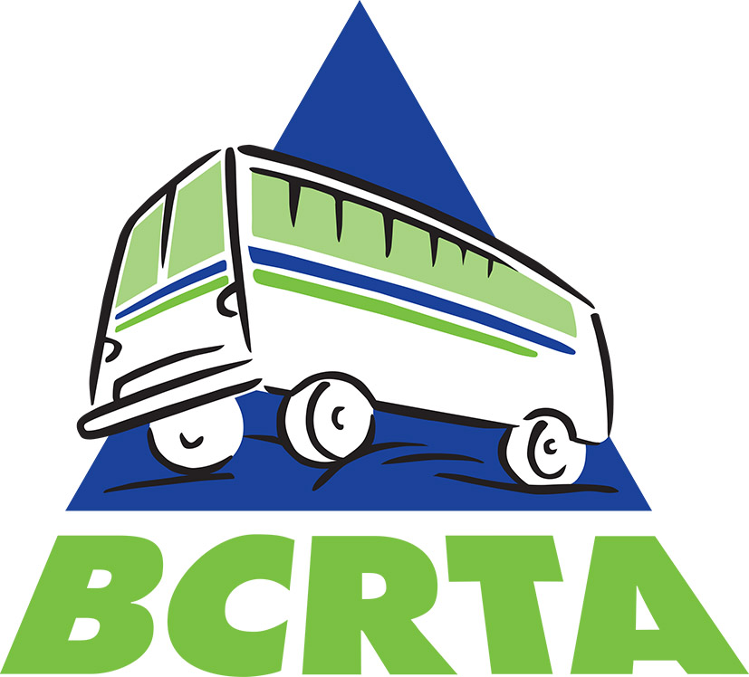
Contact:
Lisa Gatwood
Director
(513) 732-7577
Contact:
Connor Briggs
Director of Transit Operations
(513) 785-5394

FOR IMMEDIATE RELEASE
May 8, 2017

BIKE AND RIDE FOR FREE ON METRO, TANK, CTC AND BCRTA ON FRIDAY, MAY 19
Free transit rides for bicycle commuters on Bike to Work Day

CINCINNATI – Cyclists across the Greater Cincinnati region can commute for FREE on Friday, May 19, thanks to a partnership between Metro, the Transit Authority of Northern Kentucky (TANK), Clermont Transportation Connection (CTC) and Butler County Regional Transit Authority (BCRTA) to celebrate National Bike to Work Day.

The transit organizations will show bicycle commuters just how easy it is to bike and ride by offering free fare on May 19 only for riders who use the easy and convenient racks to store their bicycles while riding the bus.

Bike racks are located on the front of all Metro, TANK, CTC and BCRTA buses and can be used at all bus stops including Metro’s Government Square downtown. Each bike rack accommodates two bikes. For safety reasons, bikes are not allowed on-board buses unless they can be folded and stowed under a seat.

Metro and TANK have been recognized as “Bike Friendly Destinations” for providing advocacy and infrastructure improvements to support bicycling for employees and riders since 2011.

More information, instructions and helpful photos showing how to bike and ride can be found on Metro’s website here and on TANK’s website here.

About Metro
Metro is a non-profit, tax-funded public service of the Southwest Ohio Regional Transit Authority, providing about 15 million rides per year. Metro’s website is www.go-metro.com.

About TANK
The Transit Authority of Northern Kentucky is an integral part of the Northern Kentucky community, serving Boone, Campbell, and Kenton counties as well as downtown Cincinnati for more than 30 years. Nearly 4 million passengers each year rely on the more than 100 TANK buses throughout the region to get them where they need to be. TANK is on the web at www.tankbus.org.

About CTC
CTC is the primary provider of public transportation in Clermont County. Founded in 1977 as CART (Clermont Area Rural Transit), CTC has continued to evolve and now offers three fixed routes in addition to its Dial-A-Ride services. Visit CTC online at http://ctc.clermontcountyohio.gov.

About BCRTA
Butler County Regional Transit Authority is a public agency created in 1994 to better meet the needs of Butler County residents and to improve the quality of life and economic development through public transportation solutions. Visit BCRTA’s website at www.butlercountyrta.com.

# # #

